PROFESSIONAL (MONOCHROMATIC) COLOR PALETTE:
-PRIMARY: RGB (26,48,108)
-SUPPORTING/SECONDARY: RGB (137,137,137)
-ACCENT: RGB(0,0,0)

MODERN COLOR PALETTE:
-PRIMARY: HEX #3C36B2
-SUPPORTING/SECONDARY: HEX #897F53
-ACCENT: HEX #506C1A

PLAYFUL (TRIADIC) COLOR PALETTE:
-PRIMARY: CMYK (0,51,100,8)
-SUPPORTING/SECONDARY: CMYK (96,0,38,8)
-ACCENT: CMYK (47,61,0,8) & CMYK (0,0,0,0)

EVIL (ANALOGOUS) COLOR PALETTE:
-PRIMARY: HSL (358,100,35)
-SUPPORTING/SECONDARY: HSL (9,99,17)
-ACCENT: HSL (9,99,40) & HSL (224,100,0)

WEBPAGE ASSIGNMENT: KITTENS
-NEEDS: header, body, button, picture, footer
***push code to GitHub and upload design to Dribbble.com (make sure to save design in 1600x1200 to avoid being cut off)
COLOR SCHEME:
PRIMARY: light champagne
Medium Champagne
-CMYK (0,5,34,7)
-happiness
-elegance

SECONDARY: lilac
“Languid Lavender”
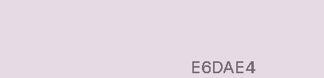
-CMYK (0,5,1,10)
-joy
ACCENT: gold/dark champagne
“Vegas Gold”
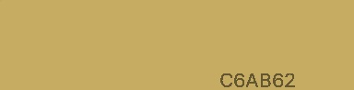
-CMYK (0,14,51,22)

-COORESPONDING PICTURE THAT WORKS WITH COLOR SCHEME
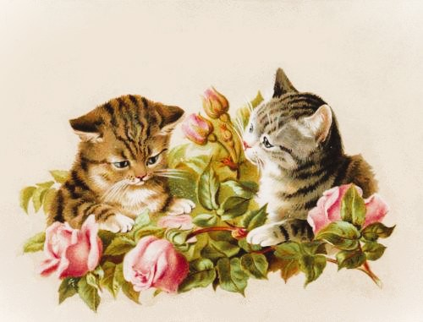
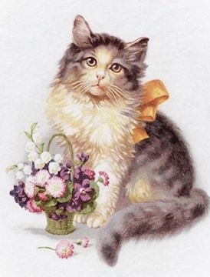

FONT FAMILY: Dancing Script, Cormorant Garamond
-HEADER FONT
Dancing Script
-BODY FONT
Cormorant Garamond
-FOOTER FONT
Cormorant Garamond

BACKGROUND COLORS:
-HEADER: light champagne
-BODY: lilac
-FOOTER: lilac

FONT COLOR:
-HEADER: dark champagne
-BODY: dark gray
-FOOTER: dark gray

